**User Story: Write user documentation for viewing student forms an account (Iteration 1)**

Task: Write user documentation for viewing student forms an account.

In order to view student submission (monthly coop report) by coop advisor, the coop advisor have to select view reports tab in his or her navigation bar (figure 1) wherein the system displays list of all monthly coop report forms submitted by different students who are assigned to respective advisor. Additionally, after selecting the tab (Student monthly report) the system will also allow coop advisor to filter the available coop reports based two criteria i.e. student ID, month (figure 2). This filter functionality is optional. If the advisor wish to use the filter option he or she have to enter student ID in the textbox and select the month from dropdown menu and finally click the filter button. This action will display the particular students’ monthly coop report.

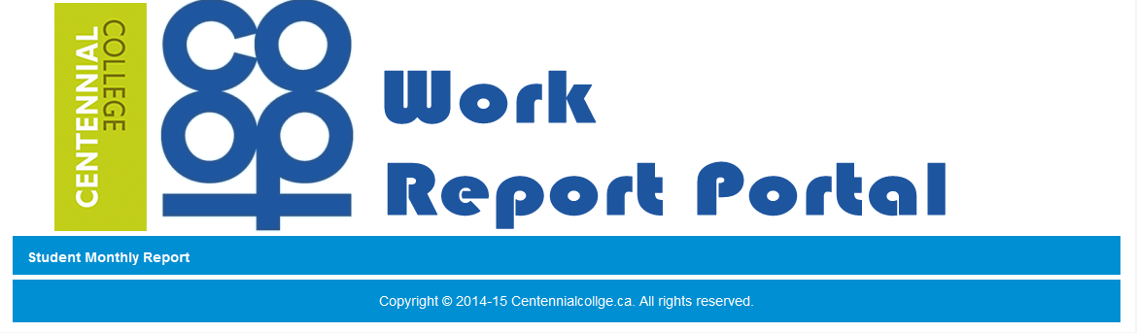

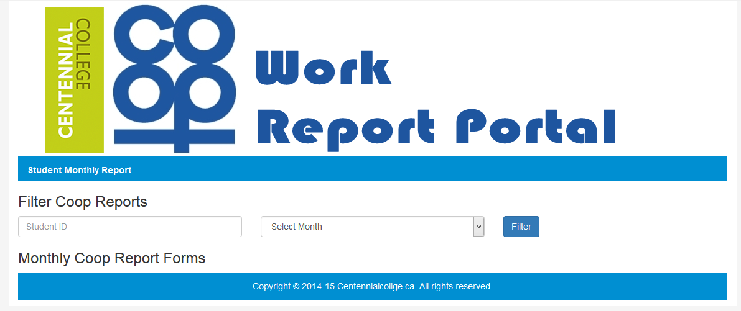 *Figure 1: CoopReporting application: student monthly report view on coop advisor page.*

*Figure 2: CoopReporting application: student monthly report to view for coop advisor*